# User Comparative Summary

## Key Information

*NOTE: For average task difficulty, results will be rounded up or down.

*NOTE: invalid not included in ranking evaluation.

|  |  |  |  |  |  |  |  |  |
| --- | --- | --- | --- | --- | --- | --- | --- | --- |
| **User** | **1** | **2** | **3** | **4** | **5** | **6** | **7** | **8** |
| **Gender** | Male | Male | Female | Female | Female | Female | Female | Female |
| **Age** | 20’s | 30’s | 30’s | 20’s | 50’s | 50’s | 20’s | 20’s |
| **Technical Ability** | Mid-high | Mid | Mid-high | Mid | Mid | Mid | Mid-high | Mid-high |
| **Website order** | RME  first | Zillow First | RME First | Zillow First | RME First | Zillow First | RME First | Zillow First |

|  |  |
| --- | --- |
| **Technical level** | **Technical lever of users (%)** |
| Low | 0 |
| Low-Mid | 0 |
| Mid | 50 |
| Mid-High | 50 |
| High | 0 |

|  |  |
| --- | --- |
| **Gender** | **User gender (%)** |
| Male | 25 |
| Female | 75 |

|  |  |
| --- | --- |
| **Age** | **User age (%)** |
| 20’s | 50 |
| 30’s | 25 |
| 40’s | 0 |
| 50’s | 25 |
| 60’s | 0 |

|  |  |  |  |  |
| --- | --- | --- | --- | --- |
| **Very Easy** | **Easy** | **Neither Easy nor Difficult** | **Difficult** | **Very Difficult** |
| 1 | 2 | 3 | 4 | 5 |

# Renting Made Easy (RME)

## Please search for rental properties in Baltimore.

|  |  |  |  |  |  |
| --- | --- | --- | --- | --- | --- |
| **Number of INVALID (X out of 8 users)** | **Highest Difficulty Ranking** | **Lowest Difficulty Ranking** | **Average Difficulty Ranking** | **Rounded Difficulty Ranking** | **Task Difficulty Result** |
| 0 | 1 | 1 | 1 | 1 | Very Easy |

|  |  |  |
| --- | --- | --- |
| **Shortest time (seconds)** | **Longest time (seconds)** | **Average time (seconds)** |
| 3.57 | 15.14 | 8.57 |

### General comments and feedback about page

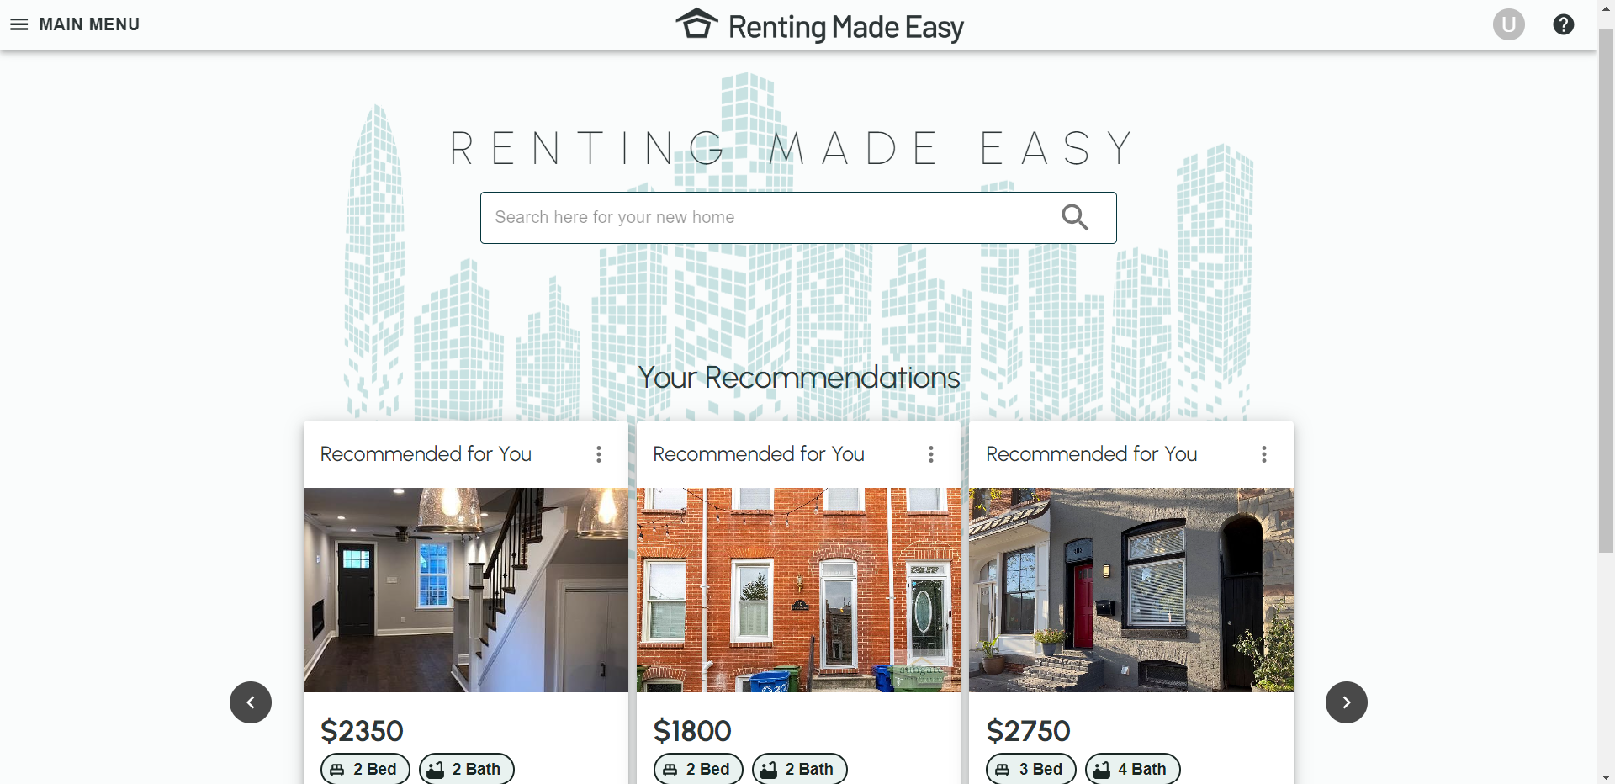

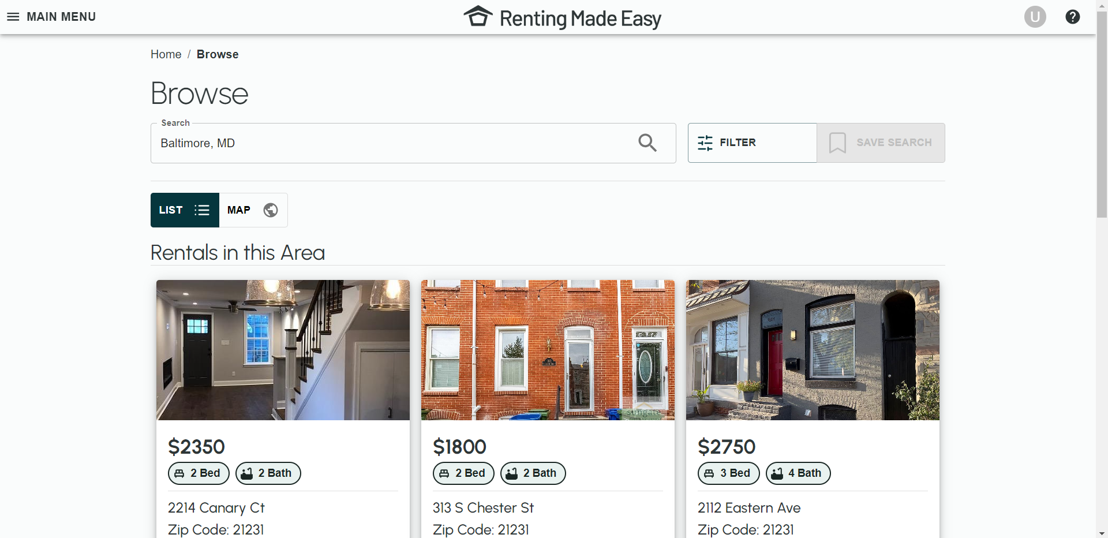

* [In general] users liked the white space/ clean look of the website.
* Better uniformity for the property thumbnail images (all outdoor or all indoor not both).
* Have an option for how may results the grid returns, e.g. option to return 12, 15, or 30.

## Can you swap to map view.

|  |  |  |  |  |  |
| --- | --- | --- | --- | --- | --- |
| **Number of INVALID (X out of 8 users)** | **Highest Difficulty Ranking** | **Lowest Difficulty Ranking** | **Average Difficulty Ranking** | **Rounded Difficulty Ranking** | **Task Difficulty Result** |
| 1 | 2 | 1 | 1.29 | 1 | Very Easy |

|  |  |  |
| --- | --- | --- |
| **Shortest time (seconds)** | **Longest time (seconds)** | **Average time (seconds)** |
| 1.16 | 29.46 | 6.46 |

### General comments and feedback about page

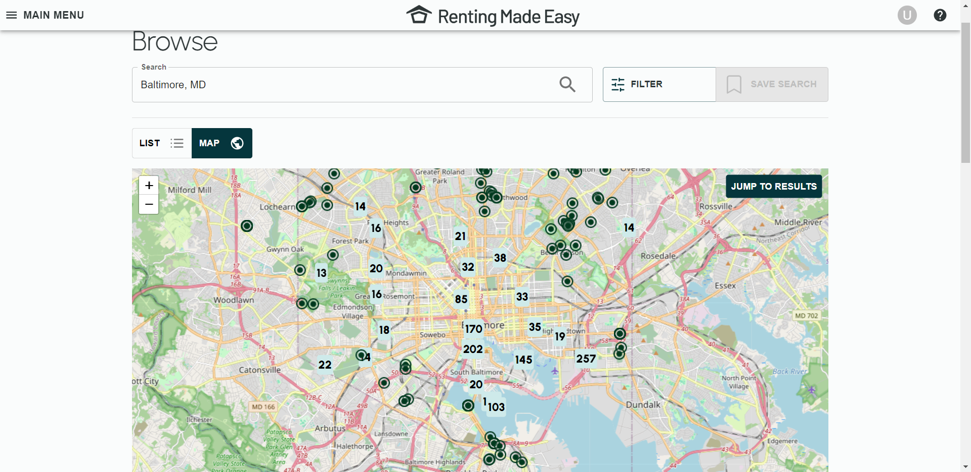

* Users initially confused about the green dots and numbers “the map is a bit confusing at first”, “I don’t really know what the numbers mean”, “I assume the dots are locations”.

## Using the map, select a property to view.

|  |  |  |  |  |  |
| --- | --- | --- | --- | --- | --- |
| **Number of INVALID (X out of 8 users)** | **Highest Difficulty Ranking** | **Lowest Difficulty Ranking** | **Average Difficulty Ranking** | **Rounded Difficulty Ranking** | **Task Difficulty Result** |
| 1 | 4 | 1 | 1.67 | 2 | Easy |

|  |  |  |
| --- | --- | --- |
| **Shortest time (seconds)** | **Longest time (seconds)** | **Average time (seconds)** |
| 1.72 | 29.44 | 7.5 |

### General comments and feedback about page

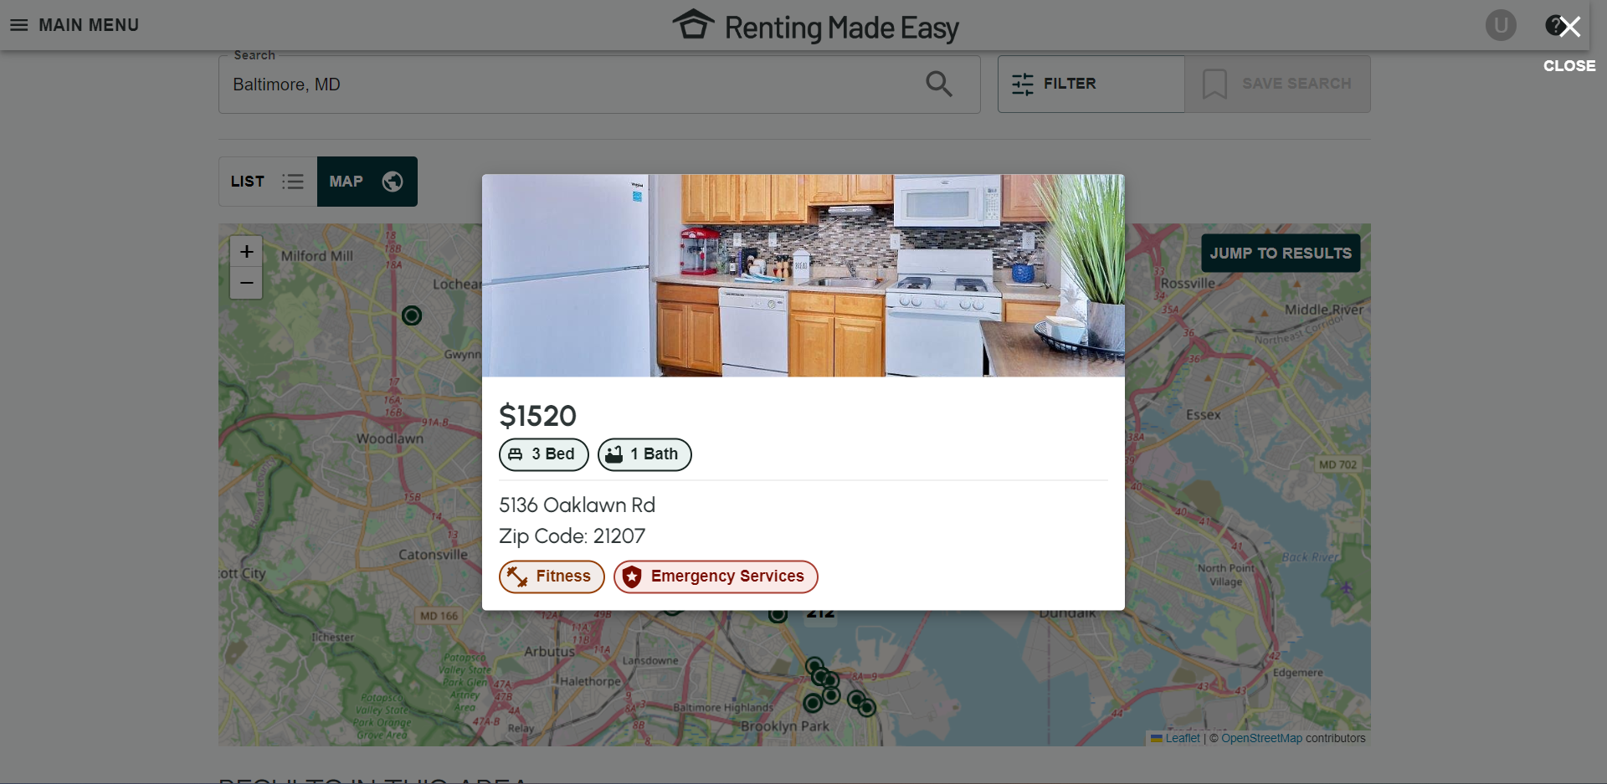

* Quick view property cards are a bit bland/ imbalanced/ lacking information.
* Thumbnail images are cut off.
* Like the tags.

## Please select the property to view in greater detail.

|  |  |  |  |  |  |
| --- | --- | --- | --- | --- | --- |
| **Number of INVALID (X out of 8 users)** | **Highest Difficulty Ranking** | **Lowest Difficulty Ranking** | **Average Difficulty Ranking** | **Rounded Difficulty Ranking** | **Task Difficulty Result** |
| 3 | 4 | 1 | 1.8 | 2 | Easy |

|  |  |  |
| --- | --- | --- |
| **Shortest time (seconds)** | **Longest time (seconds)** | **Average time (seconds)** |
| 1.02 | 4.96 | 1.79 |

### General comments and feedback about page

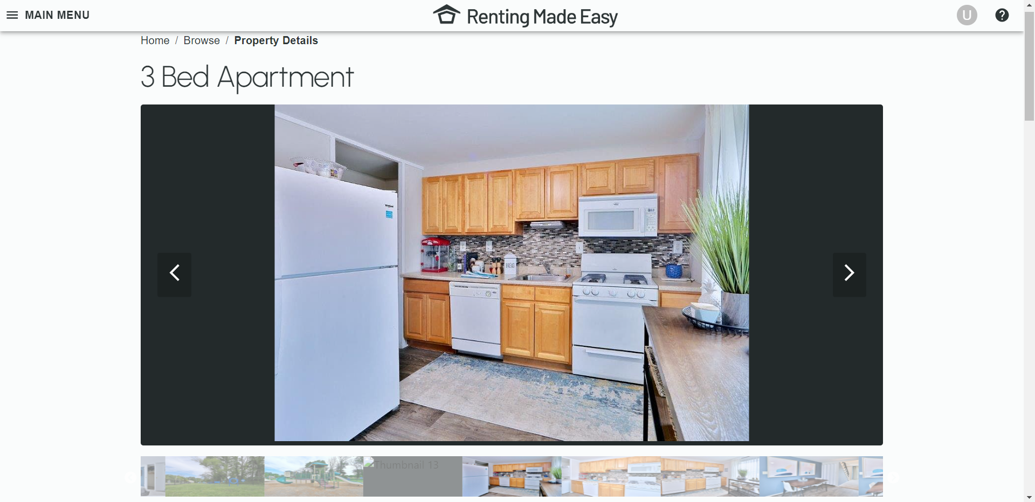

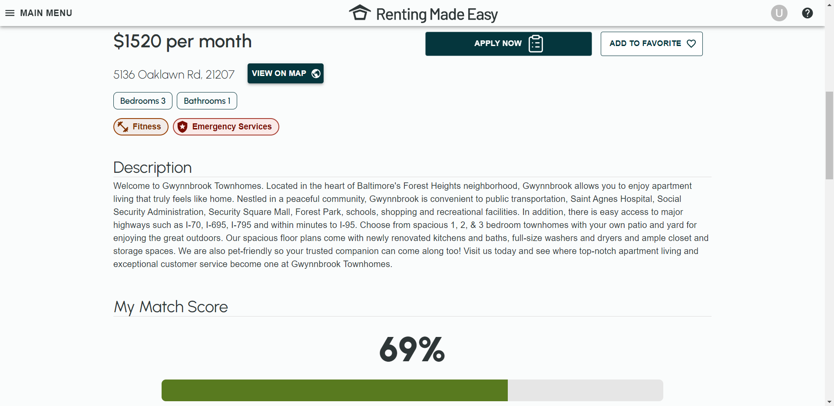

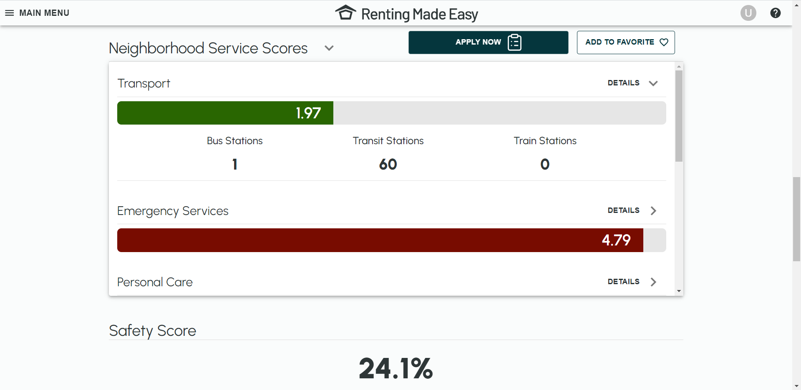

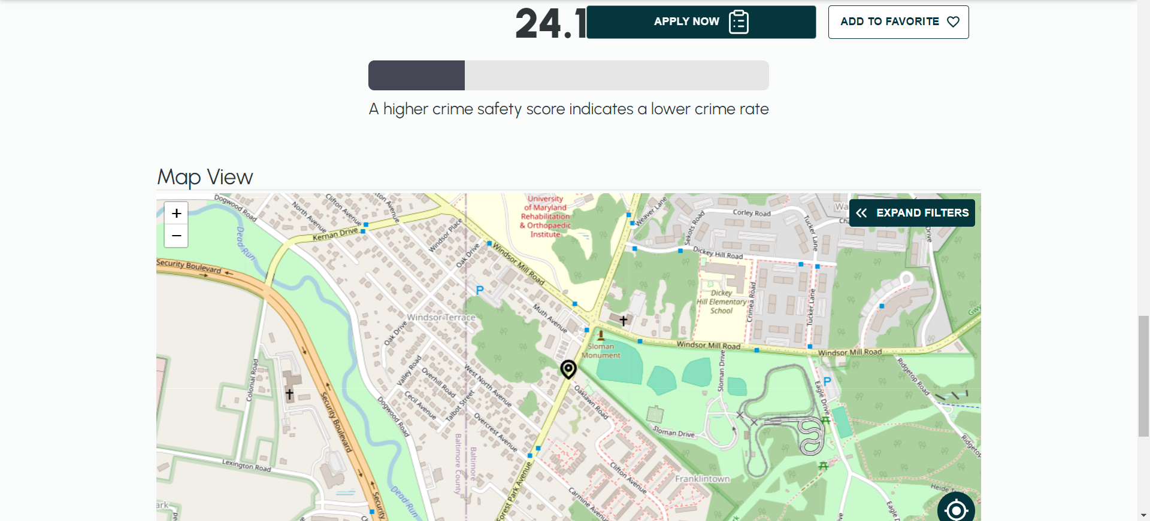

* It’s not clear where to click on the quick view property card to see more details, need a button/ link.
* Neighbourhood and safety scores are useful.
* Score scale isn’t completely clear (from 1 – 5), what is a good score? Add a tab to explain scoring.
* Having a quick summary of scores at top of property details to get quick overview before scrolling.

## Can you favourite this property?

|  |  |  |  |  |  |
| --- | --- | --- | --- | --- | --- |
| **Number of INVALID (X out of 8 users)** | **Highest Difficulty Ranking** | **Lowest Difficulty Ranking** | **Average Difficulty Ranking** | **Rounded Difficulty Ranking** | **Task Difficulty Result** |
| 0 | 2 | 1 | 1.3 | 1 | Very Easy |

|  |  |  |
| --- | --- | --- |
| **Shortest time (seconds)** | **Longest time (seconds)** | **Average time (seconds)** |
| 1.61 | 13.94 | 4.61 |

## Can you apply to this property?

|  |  |  |  |  |  |
| --- | --- | --- | --- | --- | --- |
| **Number of INVALID (X out of 8 users)** | **Highest Difficulty Ranking** | **Lowest Difficulty Ranking** | **Average Difficulty Ranking** | **Rounded Difficulty Ranking** | **Task Difficulty Result** |
| 0 | 1 | 1 | 1 | 1 | Very Easy |

|  |  |  |
| --- | --- | --- |
| **Shortest time (seconds)** | **Longest time (seconds)** | **Average time (seconds)** |
| 2.60 | 18.56 | 9.93 |

## Can you please locate your favourited properties?

|  |  |  |  |  |  |
| --- | --- | --- | --- | --- | --- |
| **Number of INVALID (X out of 8 users)** | **Highest Difficulty Ranking** | **Lowest Difficulty Ranking** | **Average Difficulty Ranking** | **Rounded Difficulty Ranking** | **Task Difficulty Result** |
| 0 | 3 | 1 | 1.6 | 2 | Easy |

|  |  |  |
| --- | --- | --- |
| **Shortest time (seconds)** | **Longest time (seconds)** | **Average time (seconds)** |
| 4.49 | 15.38 | 9.55 |

### General comments and feedback about page

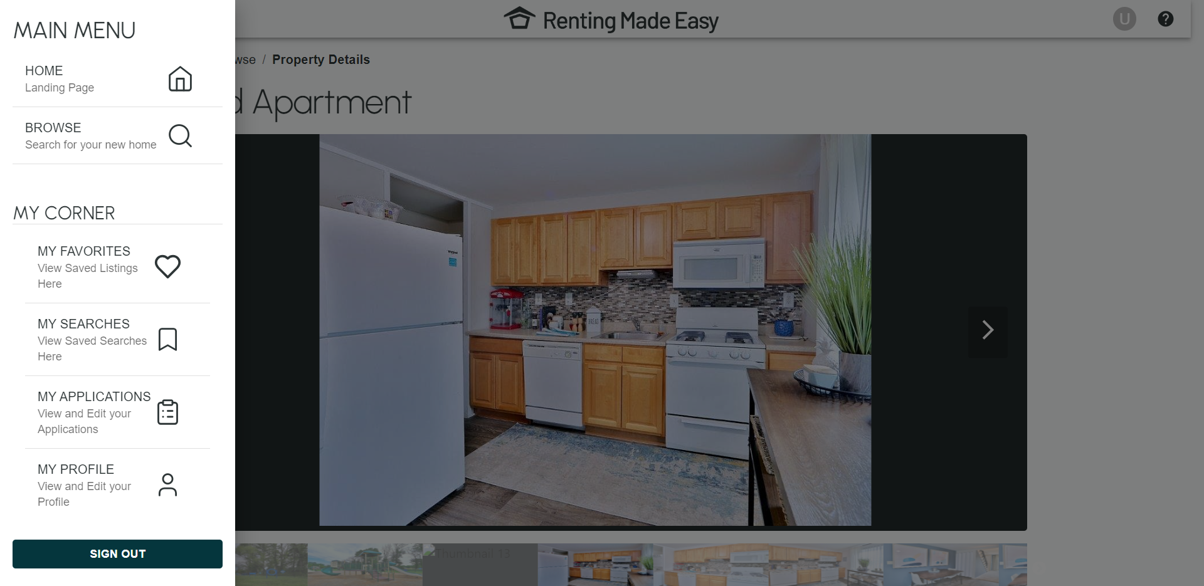

* Consider putting My Favourites next to FAQ question mark in the nav bar.

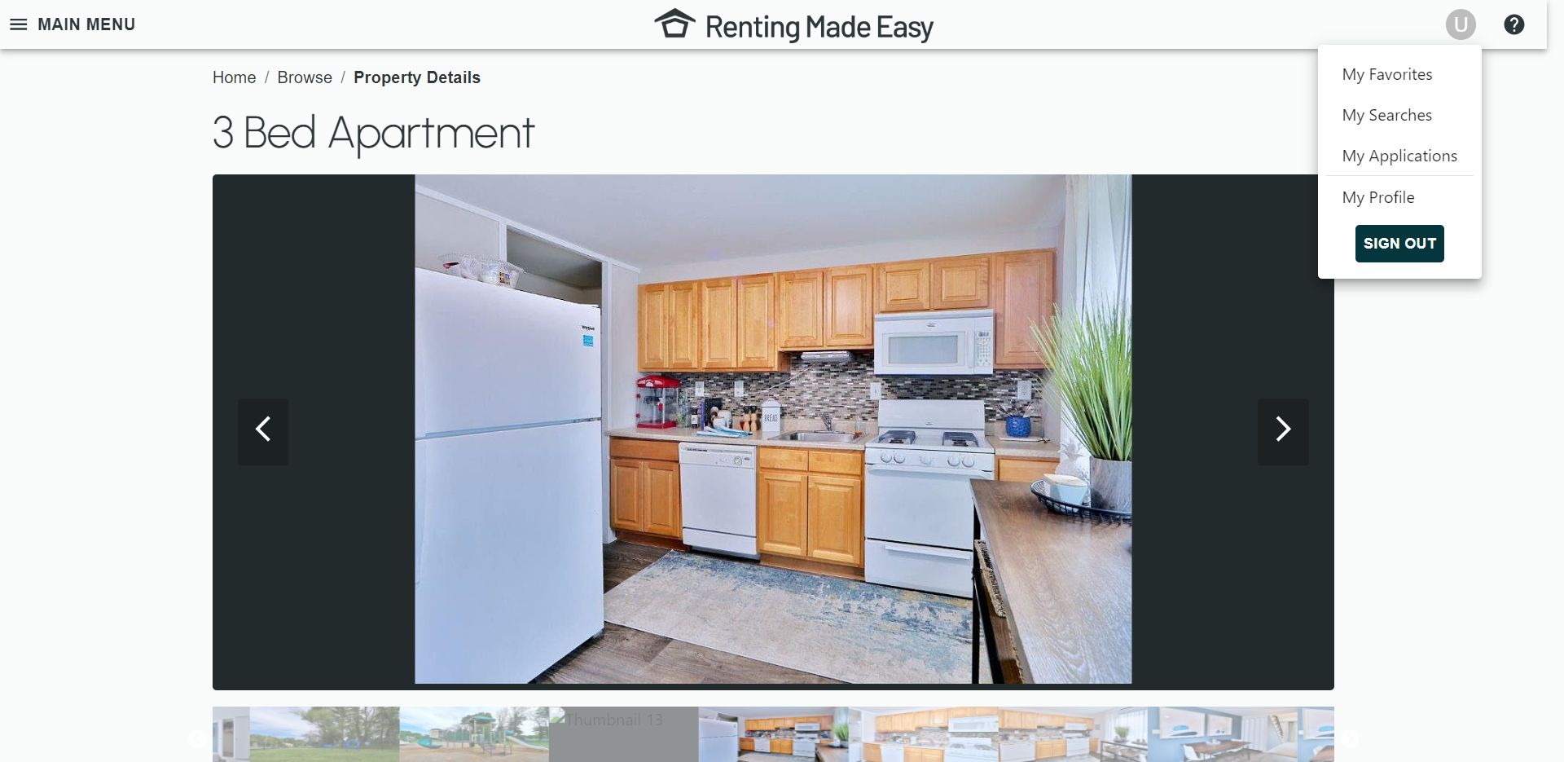

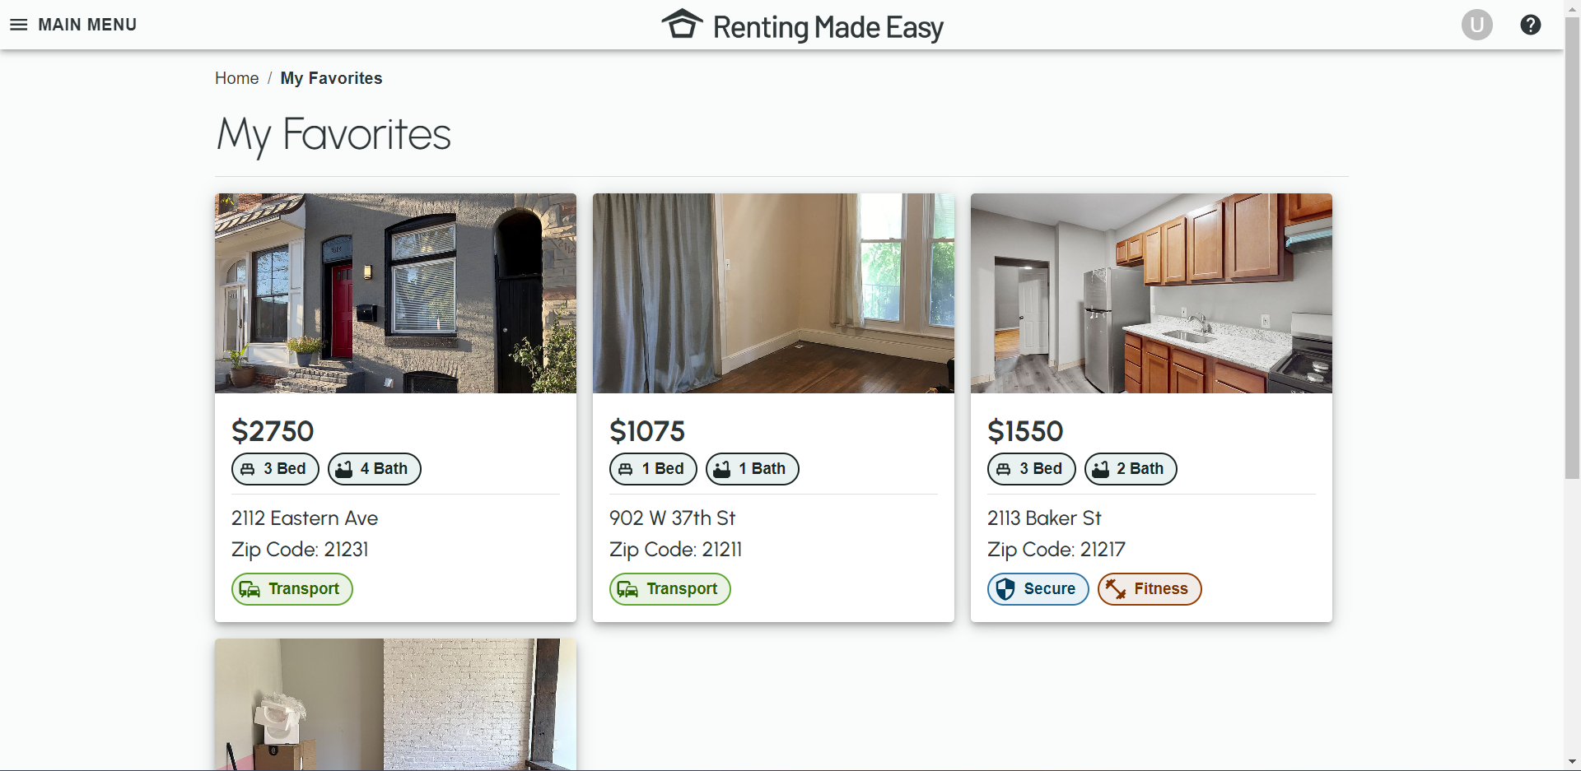

* Neat and tidy layout, possibly have a map displaying favourited property locations.

## Can you please locate your property applications?

|  |  |  |  |  |  |
| --- | --- | --- | --- | --- | --- |
| **Number of INVALID (X out of 8 users)** | **Highest Difficulty Ranking** | **Lowest Difficulty Ranking** | **Average Difficulty Ranking** | **Rounded Difficulty Ranking** | **Task Difficulty Result** |
| 0 | 3 | 1 | 1.3 | 1 | Very Easy |

|  |  |  |
| --- | --- | --- |
| **Shortest time (seconds)** | **Longest time (seconds)** | **Average time (seconds)** |
| 2.94 | 11.14 | 4.53 |

### General comments and feedback about page

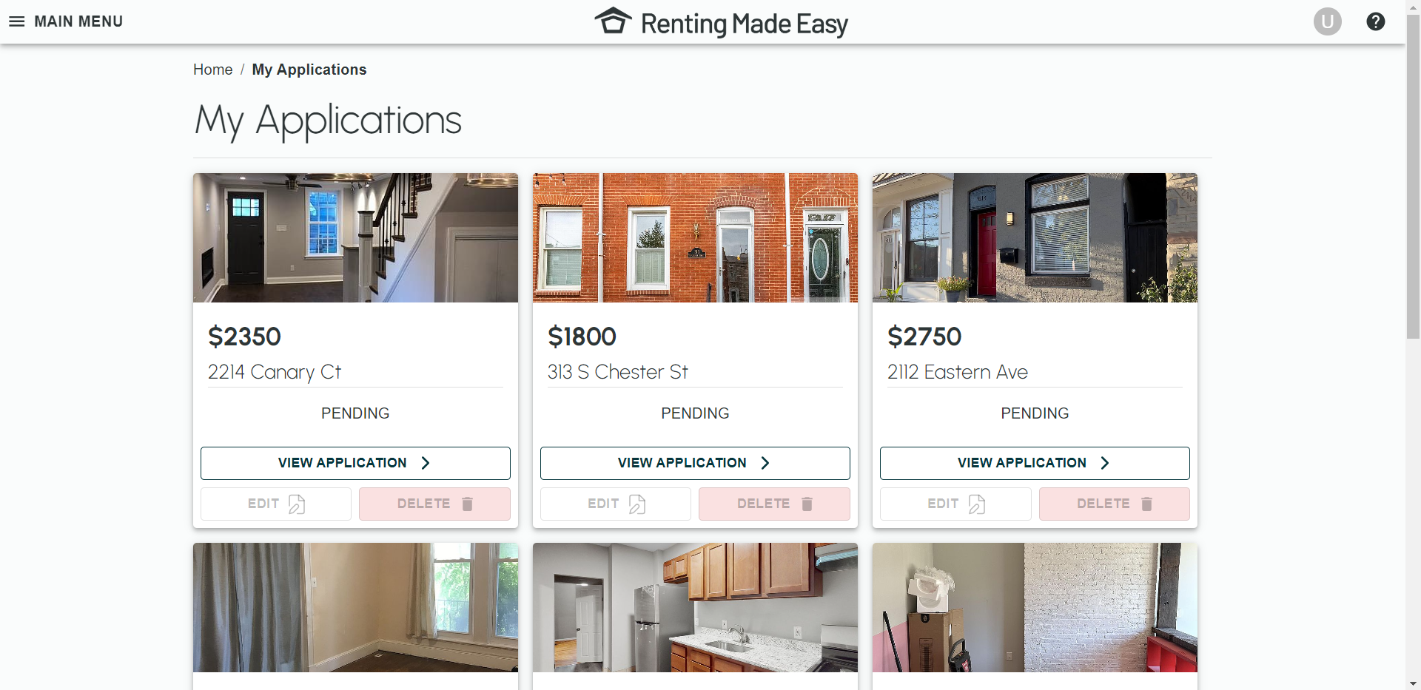

* Straightforward.
* Neat/ clean.

## Going back to browse, can you apply some filters?

|  |  |  |  |  |  |
| --- | --- | --- | --- | --- | --- |
| **Number of INVALID (X out of 8 users)** | **Highest Difficulty Ranking** | **Lowest Difficulty Ranking** | **Average Difficulty Ranking** | **Rounded Difficulty Ranking** | **Task Difficulty Result** |
| 0 | 2 | 1 | 1.3 | 1 | Very Easy |

|  |  |  |
| --- | --- | --- |
| **Shortest time (seconds)** | **Longest time (seconds)** | **Average time (seconds)** |
| 10.69 | 31.32 | 19.55 |

### General comments and feedback about page

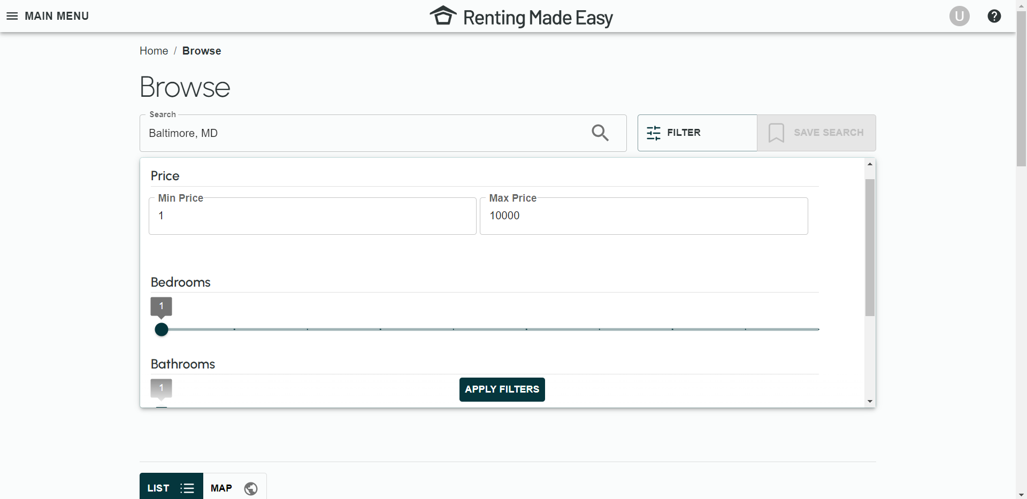

* Could have more filters available.

## Can you save your search?

|  |  |  |  |  |  |
| --- | --- | --- | --- | --- | --- |
| **Number of INVALID (X out of 8 users)** | **Highest Difficulty Ranking** | **Lowest Difficulty Ranking** | **Average Difficulty Ranking** | **Rounded Difficulty Ranking** | **Task Difficulty Result** |
| 0 | 1 | 1 | 1.3 | 1 | Very Easy |

|  |  |  |
| --- | --- | --- |
| **Shortest time (seconds)** | **Longest time (seconds)** | **Average time (seconds)** |
| 1.14 | 2.97 | 1.66 |

### General comments and feedback about page

* Have the save search button fill in after that search is saved.

## Can you please locate your saved searches?

|  |  |  |  |  |  |
| --- | --- | --- | --- | --- | --- |
| **Number of INVALID (X out of 8 users)** | **Highest Difficulty Ranking** | **Lowest Difficulty Ranking** | **Average Difficulty Ranking** | **Rounded Difficulty Ranking** | **Task Difficulty Result** |
| 0 | 2 | 1 | 1.3 | 1 | Very Easy |

|  |  |  |
| --- | --- | --- |
| **Shortest time (seconds)** | **Longest time (seconds)** | **Average time (seconds)** |
| 1.52 | 6.68 | 3.54 |

### General comments and feedback about page

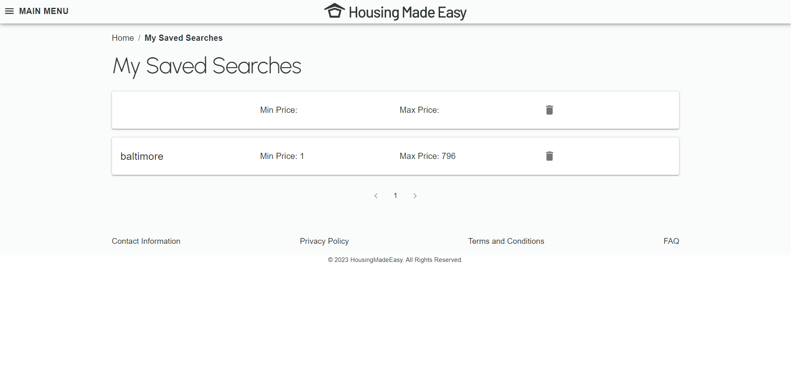

* Bit repetitive.
* Looks rather empty.
* Doesn’t show all applied filters.

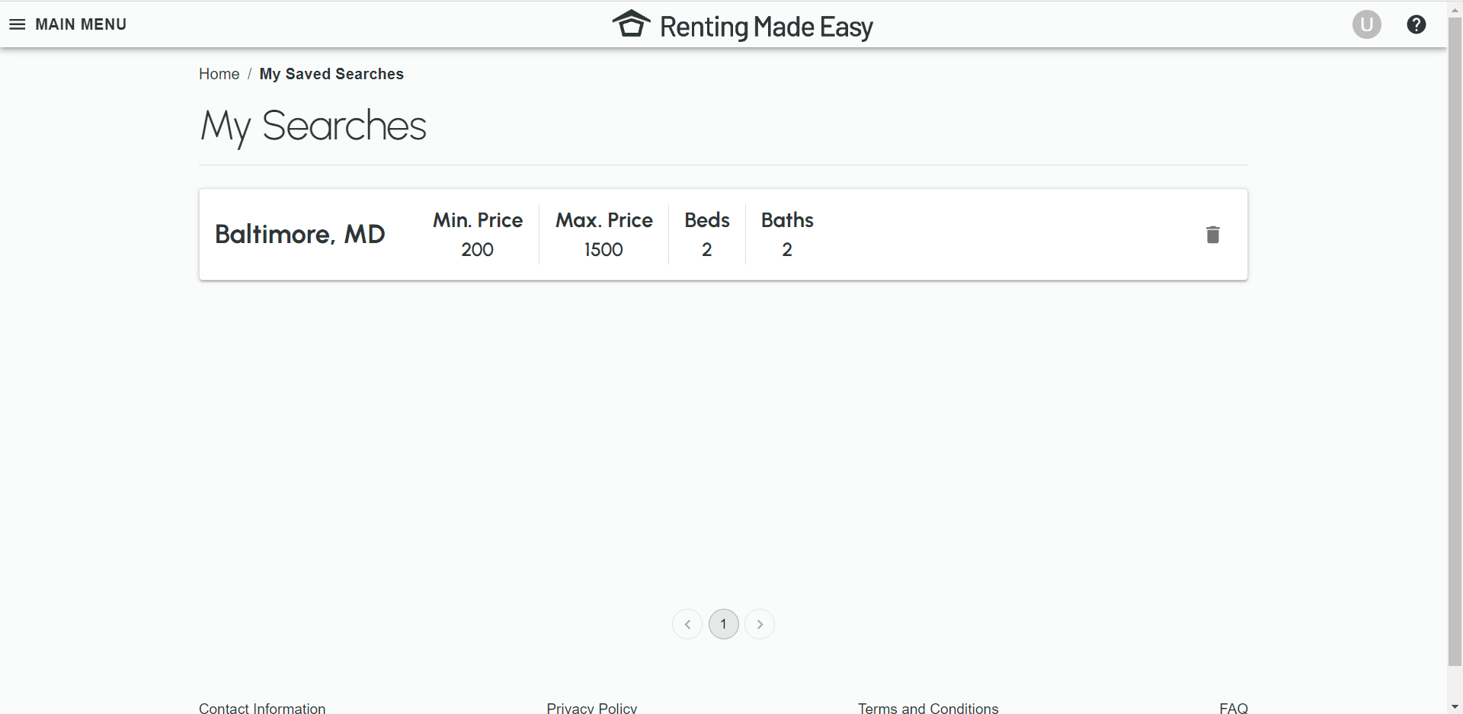

## Can you please view that saved search?

|  |  |  |  |  |  |
| --- | --- | --- | --- | --- | --- |
| **Number of INVALID (X out of 8 users)** | **Highest Difficulty Ranking** | **Lowest Difficulty Ranking** | **Average Difficulty Ranking** | **Rounded Difficulty Ranking** | **Task Difficulty Result** |
| 2 | 2 | 1 | 1.2 | 1 | Very Easy |

|  |  |  |
| --- | --- | --- |
| **Shortest time (seconds)** | **Longest time (seconds)** | **Average time (seconds)** |
| 0.50 | 9.08 | 2.55 |

## Can you please delete that saved search?

|  |  |  |  |  |  |
| --- | --- | --- | --- | --- | --- |
| **Number of INVALID (X out of 8 users)** | **Highest Difficulty Ranking** | **Lowest Difficulty Ranking** | **Average Difficulty Ranking** | **Rounded Difficulty Ranking** | **Task Difficulty Result** |
| 0 | 2 | 1 | 1.3 | 1 | Very Easy |

|  |  |  |
| --- | --- | --- |
| **Shortest time (seconds)** | **Longest time (seconds)** | **Average time (seconds)** |
| 0.50 | 9.08 | 1.66 |

## General website comments and suggestions

* Have a walkthrough/ tutorial for new users.
* Users liked clean/ tidy look of website i.e., lots of white space.
* Users like the simplicity.
* Liked features and amenities (neighbourhood service/ crime scores).
* Odd to have “My Preferences” in “My Profile”.
* Changing the colour of the nav bar to better distinguish between browser search and website search.

# Zillow

## Enter Baltimore into the search.

|  |  |  |  |  |  |
| --- | --- | --- | --- | --- | --- |
| **Number of INVALID (X out of 8 users)** | **Highest Difficulty Ranking** | **Lowest Difficulty Ranking** | **Average Difficulty Ranking** | **Rounded Difficulty Ranking** | **Task Difficulty Result** |
| 0 | 2 | 1 | 1.3 | 1 | Very Easy |

|  |  |  |
| --- | --- | --- |
| **Shortest time (seconds)** | **Longest time (seconds)** | **Average time (seconds)** |
| 5.40 | 11.49 | 7.30 |

### General comments and feedback about page

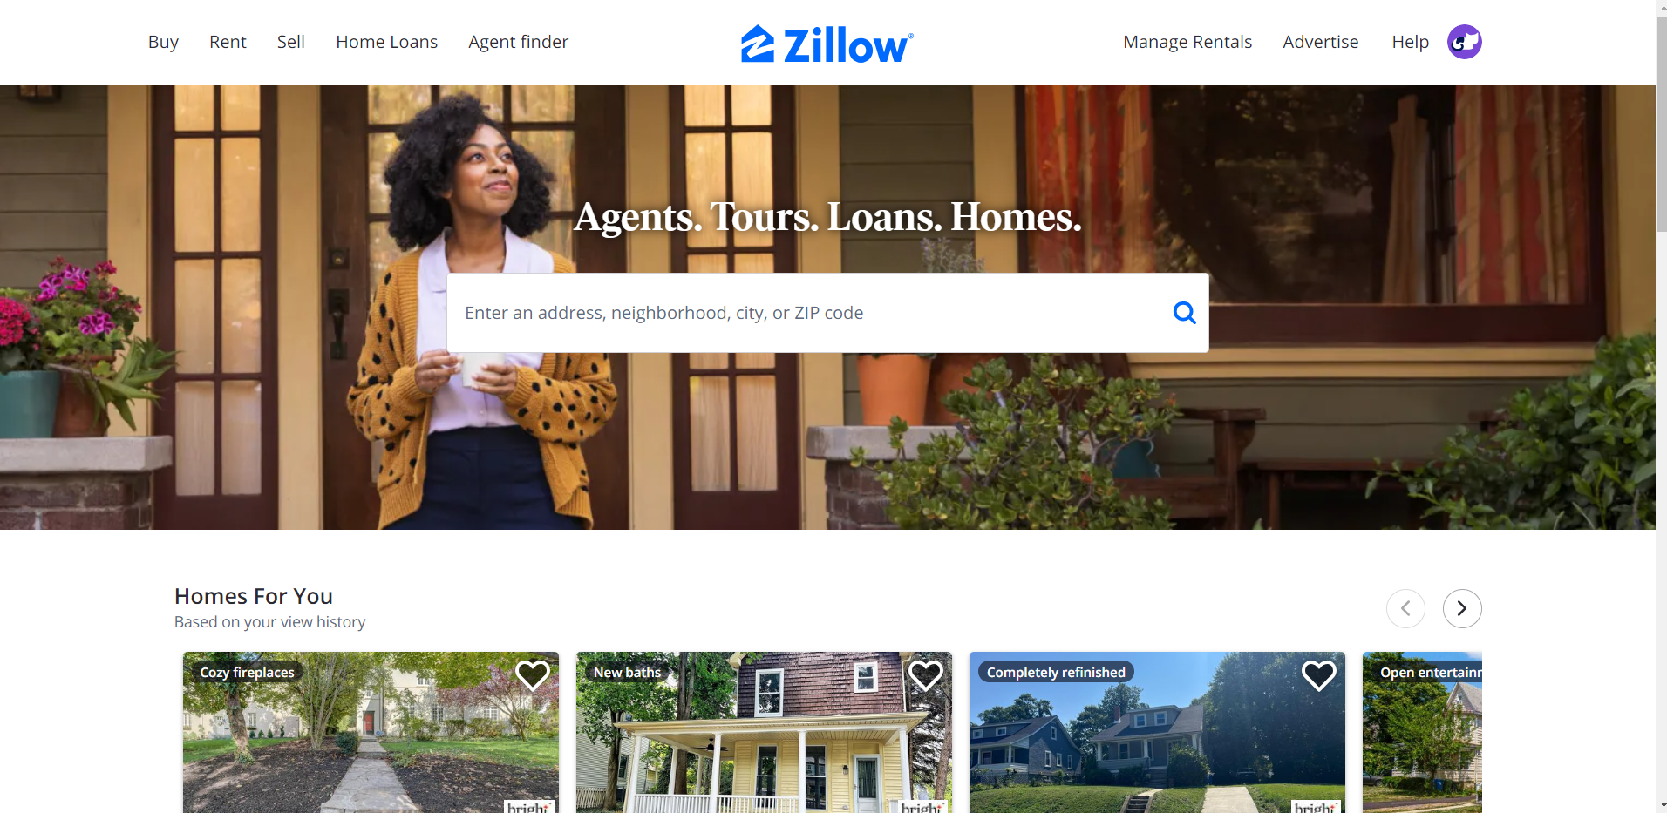

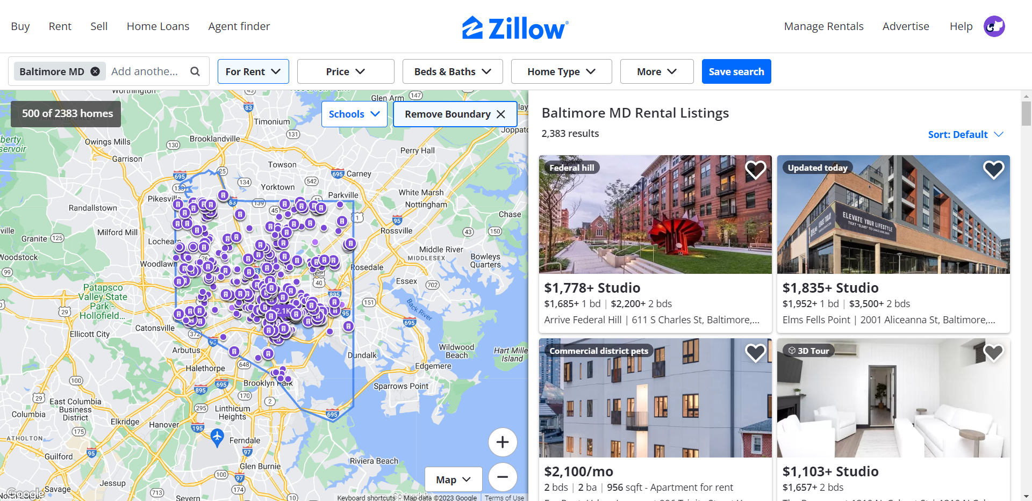

* Cognitive overload/ page very cluttered.
* Makes sense/ able to understand layout.
* Like the map on the side and that Baltimore region is highlighted.

## [OPTIONAL -> Only if “For Sale” properties displaying] Can you change the results to For Rent.

|  |  |  |  |  |  |
| --- | --- | --- | --- | --- | --- |
| **Number of INVALID (X out of 2 users)** | **Highest Difficulty Ranking** | **Lowest Difficulty Ranking** | **Average Difficulty Ranking** | **Rounded Difficulty Ranking** | **Task Difficulty Result** |
| 1 | 2 | 2 | 2 | 2 | Easy |

|  |  |  |
| --- | --- | --- |
| **Shortest time (seconds)** | **Longest time (seconds)** | **Average time (seconds)** |
| 24.89 | 24.89 | 24.89 |

### General comments and feedback about page

* Where to change to “For Rent” not immediately clear to user, user expressed For Sale/ For Rent should be a header.

## Using the map, select a property to view.

|  |  |  |  |  |  |
| --- | --- | --- | --- | --- | --- |
| **Number of INVALID (X out of 8 users)** | **Highest Difficulty Ranking** | **Lowest Difficulty Ranking** | **Average Difficulty Ranking** | **Rounded Difficulty Ranking** | **Task Difficulty Result** |
| 1 | 3 | 1 | 1.6 | 2 | Easy |

|  |  |  |
| --- | --- | --- |
| **Shortest time (seconds)** | **Longest time (seconds)** | **Average time (seconds)** |
| 2.49 | 11.11 | 6.42 |

### General comments and feedback about page

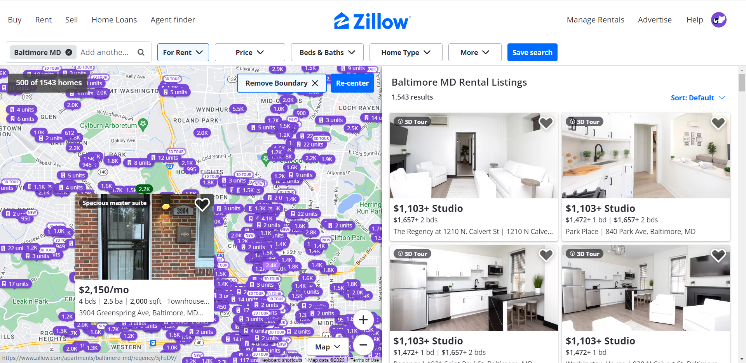

* What does 1.4K mean, it would be better if it was $1.4K or a house icon.
* It’s good to see when the property was uploaded to the website as well as detail (bedrooms, bathrooms etc).
* Looks cramped, there are so many points it’s hard to view.

## Please select the property to view in greater detail.

|  |  |  |  |  |  |
| --- | --- | --- | --- | --- | --- |
| **Number of INVALID (X out of 8 users)** | **Highest Difficulty Ranking** | **Lowest Difficulty Ranking** | **Average Difficulty Ranking** | **Rounded Difficulty Ranking** | **Task Difficulty Result** |
| 4 | 4 | 1 | 1.8 | 2 | Easy |

|  |  |  |
| --- | --- | --- |
| **Shortest time (seconds)** | **Longest time (seconds)** | **Average time (seconds)** |
| 0.88 | 30.03 | 8.08 |

### General comments and feedback about page

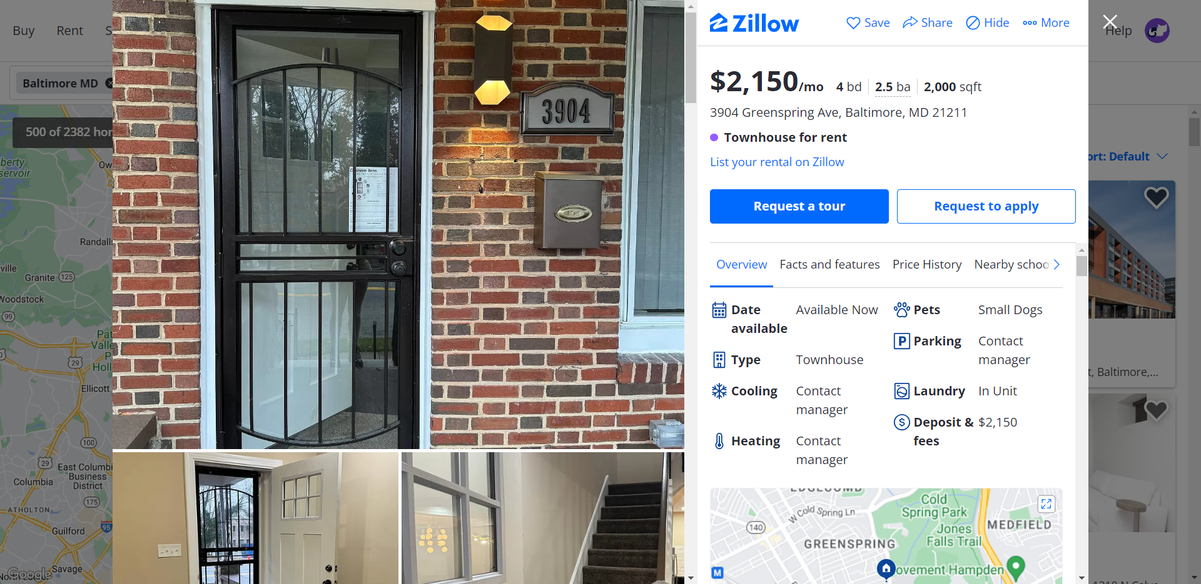

* Liked not having to leave the results page to view property in depth.
* Would prefer to have a separate page not a modal.
* A lot of information, cluttered.
* What is bd (bedrooms) and ba (bathrooms)?

## Can you save this property?

|  |  |  |  |  |  |
| --- | --- | --- | --- | --- | --- |
| **Number of INVALID (X out of 8 users)** | **Highest Difficulty Ranking** | **Lowest Difficulty Ranking** | **Average Difficulty Ranking** | **Rounded Difficulty Ranking** | **Task Difficulty Result** |
| 1 | 2 | 1 | 1.4 | 1 | Very Easy |

|  |  |  |
| --- | --- | --- |
| **Shortest time (seconds)** | **Longest time (seconds)** | **Average time (seconds)** |
| 2.56 | 7.87 | 3.64 |

## Can you apply to this property, do not actually submit the application?

|  |  |  |  |  |  |
| --- | --- | --- | --- | --- | --- |
| **Number of INVALID (X out of 8 users)** | **Highest Difficulty Ranking** | **Lowest Difficulty Ranking** | **Average Difficulty Ranking** | **Rounded Difficulty Ranking** | **Task Difficulty Result** |
| 2 | 1 | 1 | 1 | 1 | Very Easy |

|  |  |  |
| --- | --- | --- |
| **Shortest time (seconds)** | **Longest time (seconds)** | **Average time (seconds)** |
| 1.30 | 4.20 | 2.61 |

## Can you please locate your saved properties?

|  |  |  |  |  |  |
| --- | --- | --- | --- | --- | --- |
| **Number of INVALID (X out of 8 users)** | **Highest Difficulty Ranking** | **Lowest Difficulty Ranking** | **Average Difficulty Ranking** | **Rounded Difficulty Ranking** | **Task Difficulty Result** |
| 1 | 5 | 1 | 3.3 | 3 | Neither Easy nor Difficult |

|  |  |  |
| --- | --- | --- |
| **Shortest time (seconds)** | **Longest time (seconds)** | **Average time (seconds)** |
| 2.55 | 50 + | 8.56  **Tester had to indicate correct location to some users, those times not included in average. |

### General comments and feedback about page

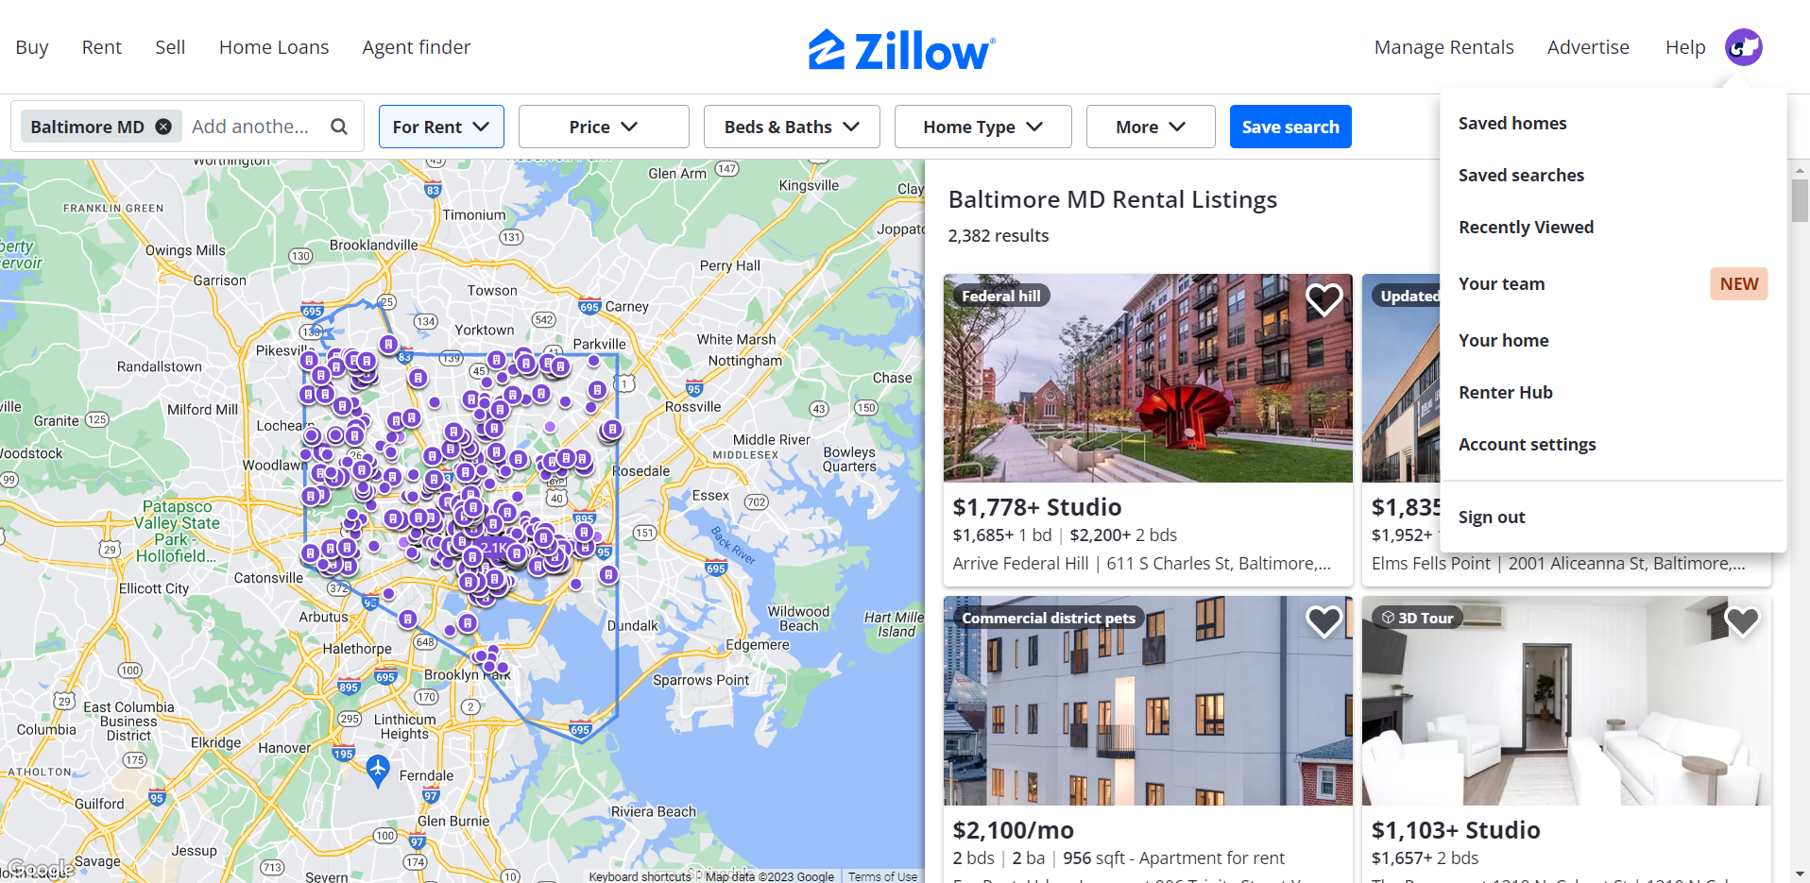

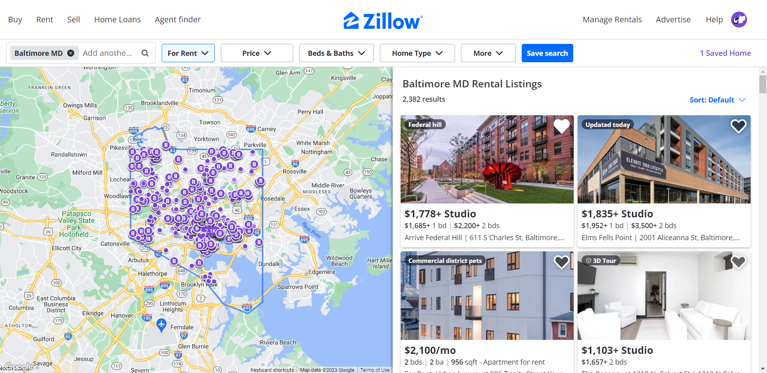

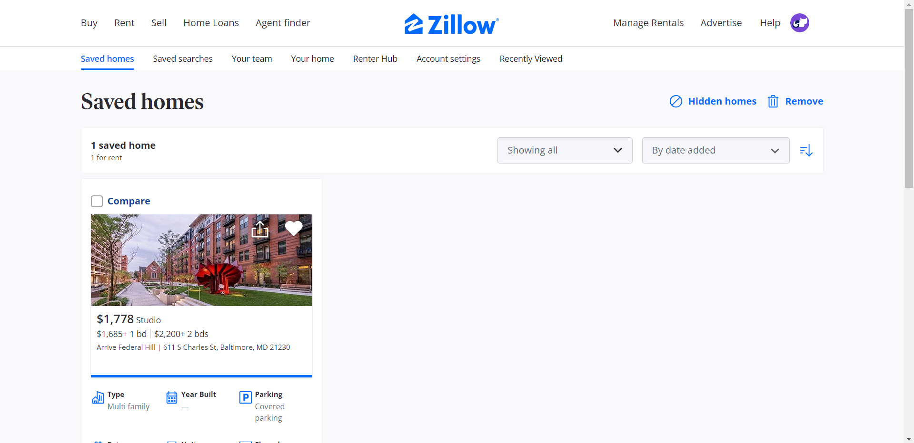

* Not intuitive where to look, it looks like a logo/ didn’t realise that was “My Profile” picture.
* Didn’t like clicking out of property details.

## Going back to browse, can you apply some filters?

|  |  |  |  |  |  |
| --- | --- | --- | --- | --- | --- |
| **Number of INVALID (X out of 8 users)** | **Highest Difficulty Ranking** | **Lowest Difficulty Ranking** | **Average Difficulty Ranking** | **Rounded Difficulty Ranking** | **Task Difficulty Result** |
| 1 | 4 | 1 | 2.1 | 2 | Easy |

|  |  |  |
| --- | --- | --- |
| **Shortest time (seconds)** | **Longest time (seconds)** | **Average time (seconds)** |
| 8.24 | 54.96 | 26.67 |

## Can you save your search?

|  |  |  |  |  |  |
| --- | --- | --- | --- | --- | --- |
| **Number of INVALID (X out of 8 users)** | **Highest Difficulty Ranking** | **Lowest Difficulty Ranking** | **Average Difficulty Ranking** | **Rounded Difficulty Ranking** | **Task Difficulty Result** |
| 0 | 5 | 1 | 1.3 | 1 | Very Easy |

|  |  |  |
| --- | --- | --- |
| **Shortest time (seconds)** | **Longest time (seconds)** | **Average time (seconds)** |
| 1.89 | 6.33 | 1.95 |

## Can you please locate your saved searches?

|  |  |  |  |  |  |
| --- | --- | --- | --- | --- | --- |
| **Number of INVALID (X out of 8 users)** | **Highest Difficulty Ranking** | **Lowest Difficulty Ranking** | **Average Difficulty Ranking** | **Rounded Difficulty Ranking** | **Task Difficulty Result** |
| 0 | 3 | 1 | 2.8 | 3 | Neither Easy nor Difficult |

|  |  |  |
| --- | --- | --- |
| **Shortest time (seconds)** | **Longest time (seconds)** | **Average time (seconds)** |
| 4.23 | 41.89 | 14.20  **Tester had to indicate correct location to some users, those times not included in average. |

### General comments and feedback about page

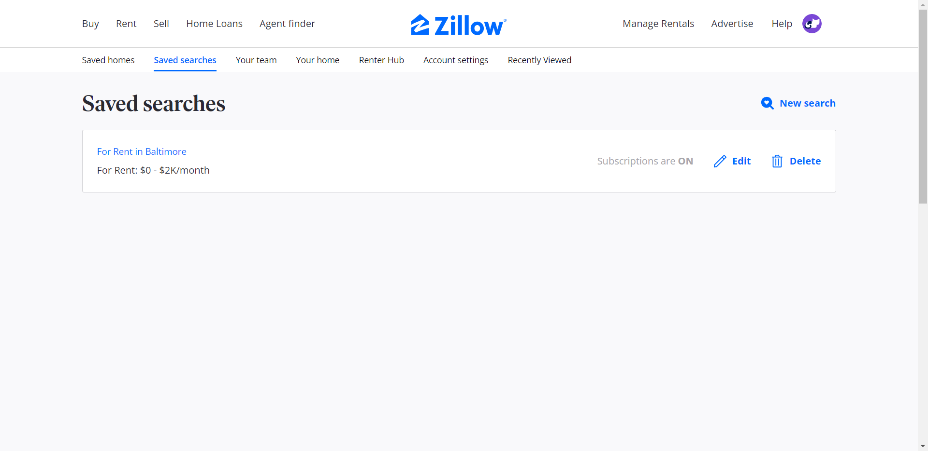

* If I was finding saved searches for the first time, I would say difficulty level = 5.
* Not intuitive going to saved homes/ clicking something irrelevant then saved searches.

## How would you view that saved search?

|  |  |  |  |  |  |
| --- | --- | --- | --- | --- | --- |
| **Number of INVALID (X out of 8 users)** | **Highest Difficulty Ranking** | **Lowest Difficulty Ranking** | **Average Difficulty Ranking** | **Rounded Difficulty Ranking** | **Task Difficulty Result** |
| 1 | 5 | 1 | 1.9 | 2 | Easy |

|  |  |  |
| --- | --- | --- |
| **Shortest time (seconds)** | **Longest time (seconds)** | **Average time (seconds)** |
| 2.39 | 17.96 | 5.63 |

Please return to saved searches and delete that saved search.

|  |  |  |  |  |  |
| --- | --- | --- | --- | --- | --- |
| **Number of INVALID (X out of 8 users)** | **Highest Difficulty Ranking** | **Lowest Difficulty Ranking** | **Average Difficulty Ranking** | **Rounded Difficulty Ranking** | **Task Difficulty Result** |
| 2 | 4 | 1 | 1.5 | 2 | Easy |

|  |  |  |
| --- | --- | --- |
| **Shortest time (seconds)** | **Longest time (seconds)** | **Average time (seconds)** |
| 8.81 | 21.80 | 12.77 |

## General website comments and suggestions

* Don’t like that key functionality is hidden behind unassuming profile picture.
* Like having person on home page.
* Very cluttered and difficult to navigate.
* Like Map Boundary.

# RME VS Zillow

Website that had lowest difficulty ranking = green

Websites have the same ranking = black

|  |  |  |
| --- | --- | --- |
| **Users that prefer RME (%)** | **Users that prefer Zillow(%)** | **Users that didn’t specify (%)** |
| 50 | 12.5 | 37.5 |

## Search for Baltimore.

|  |  |  |  |
| --- | --- | --- | --- |
| **Task Difficulty RME** | **Average Time RME (seconds)** | **Task Difficulty Zillow** | **Average Time Zillow (seconds)** |
| Very Easy | 8.57 | Very Easy | 1.66 |

## Quick view using map.

|  |  |  |  |
| --- | --- | --- | --- |
| **Task Difficulty RME** | **Average Time RME (seconds)** | **Task Difficulty Zillow** | **Average Time Zillow (seconds)** |
| Easy | 7.5 | Easy | 6.42 |

## View property details (using map).

|  |  |  |  |
| --- | --- | --- | --- |
| **Task Difficulty RME** | **Average Time RME (seconds)** | **Task Difficulty Zillow** | **Average Time Zillow (seconds)** |
| Easy | 1.79 | Easy | 8.08 |

## Favourite/ save the property.

|  |  |  |  |
| --- | --- | --- | --- |
| **Task Difficulty RME** | **Average Time RME (seconds)** | **Task Difficulty Zillow** | **Average Time Zillow (seconds)** |
| Very Easy | 4.61 | Very Easy | 3.64 |

## Apply to the property.

|  |  |  |  |
| --- | --- | --- | --- |
| **Task Difficulty RME** | **Average Time RME (seconds)** | **Task Difficulty Zillow** | **Average Time Zillow (seconds)** |
| Very Easy | 9.93 | Very Easy | 2.61 |

## Locate favourited/ saved properties.

|  |  |  |  |
| --- | --- | --- | --- |
| **Task Difficulty RME** | **Average Time RME (seconds)** | **Task Difficulty Zillow** | **Average Time Zillow (seconds)** |
| Easy | 9.55 | Neither Easy nor Difficult | 8.56 |

## Apply filters.

|  |  |  |  |
| --- | --- | --- | --- |
| **Task Difficulty RME** | **Average Time RME (seconds)** | **Task Difficulty Zillow** | **Average Time Zillow (seconds)** |
| Very Easy | 19.55 | Easy | 26.67 |

## Save Search.

|  |  |  |  |
| --- | --- | --- | --- |
| **Task Difficulty RME** | **Average Time RME (seconds)** | **Task Difficulty Zillow** | **Average Time Zillow (seconds)** |
| Very Easy | 1.66 | Very Easy | 1.95 |

## Locate saved searches.

|  |  |  |  |
| --- | --- | --- | --- |
| **Task Difficulty RME** | **Average Time RME (seconds)** | **Task Difficulty Zillow** | **Average Time Zillow (seconds)** |
| Very Easy | 3.54 | Neither Easy nor Difficult | 14.20 |

## View saved search.

|  |  |  |  |
| --- | --- | --- | --- |
| **Task Difficulty RME** | **Average Time RME (seconds)** | **Task Difficulty Zillow** | **Average Time Zillow (seconds)** |
| Very Easy | 2.55 | Easy | 5.63 |

## Delete saved search.

|  |  |  |  |
| --- | --- | --- | --- |
| **Task Difficulty RME** | **Average Time RME (seconds)** | **Task Difficulty Zillow** | **Average Time Zillow (seconds)** |
| Very Easy | 1.66 | Easy | 12.77 |

## Discussion

Overall RME had the same difficulty rankings as Zillow or better difficulty rankings. Most users preferred RME with comments such as simple and clean being mentioned, a direct contrast to Zillow’s cluttered and over-whelming layout. There are some issues with the interview that must be discussed.

There may have been some bias with questions asked for example, “Do you think the neighbourhood service scores are useful?” The user is forced to give an absolute, yes/ no. By restructuring the format of the question, testers would get more nuanced responses “On a scale of 1 – 5, with 1 being very useful and 5 being not very useful, how would you rank the neighbourhood service scores?”

The times are not reflective of the difficulty of the task itself, as can be seen from the results. The times may also have inconsistencies due to the INVALIDS within various fields. The inconsistencies may be skewing the results of the averages (rank and time) to be more, or less favourable. These inconsistencies could be related to the semi-structured nature of the interview. Despite the multiple testers having the same script, there was some variation in terms of wording which may impact user comprehension. In the future a single tester for the interviews would mitigate this variation however this may lead to bias in favour of the tester’s website. To counteract possible bias, multiple forms of analysis would be necessary from a variety of testers.

Overall, this comparative testing revealed possible avenues of future work for RME. However future work will be discussed later within this report (SECTION).